**Effects in a DOF ROM to Work with DOFLinx – Version 8.12**

*This guide is designed to help the people that want to add or edit effects to a DOF ROM that is used by DOFLinx for FX, FX3 and MAME. If you just want to play pinball, you don’t need this guide.*

So, you’ve decided that you want to add some specific effects to a DOF ROM that FX2, FX3, FX or MAME games use. Well, it is important to understand that this **DOES NOT** work like it does for VPX. If you add / setup many devices in a ROM used by DOFLinx you will likely break the way toys work for you and others. DOFLinx drives toys directly, FX games do not have or understand a ROM, DOFLinx interprets (or Links DOF) with FX2, FX3, FX and MAME.

A few people wanted to setup some extra effects so I have made some changes from DOFLinx V7.24 to allow as much of this as I can. Have a read, be careful, and ultimately try one and check that there are no adverse effects for you or others.

For clarity, we are talking about the DOF config tool table config found here <http://configtool.vpuniverse.com/tableconfig.php>

There are 10, and 10 only items that can be added to the public profile. They are highlighted below. Adding a public configuration that will work for everyone to these MX effects is OK, DOFLinx will work with these from v7.24.

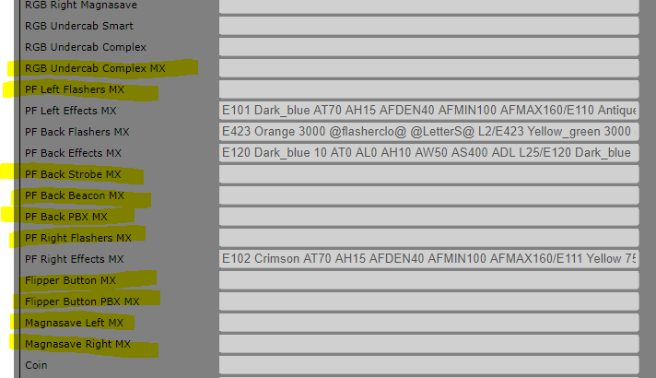

The public profile means that you will see it in the left column as per the header below.



If you want to do something just for your cabinet that is fine too. Just add it to your profile on the right, save it as circled below, but do not submit for public consideration (under the X), just use the ticked generate config option. If you do have a private config please be very careful that you do not accidentally try and submit it publicly. There is no ‘review board’ for these ROMS, they simply go out to everyone.

